1. Define the following terms:

- Physical Features

- Human Features

- Region

- Population

- Borders

- Government

2. What are the 5 geographic regions in the United States?

3. Draw the 5 regions on this map and label each region
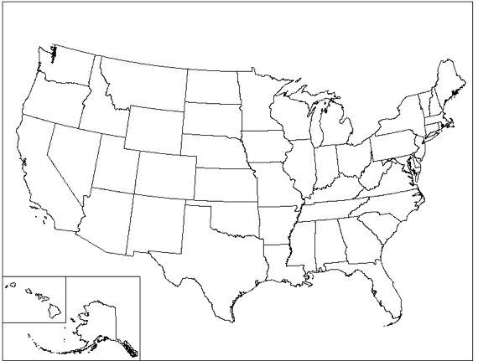
4. Examples of regions that have borders

5. Examples of how regions are used

6. How do regions help or hurt people?

7. Examples of how regions are defined

